SDD4007 Whole Person Development:
Enhancing Competencies in the 21st Century Workplace

EA: Mock Interview Exercise - Career Plan & CV

Name of Student: Owen Wong Student No.: 240108088 Programme: Higher Diploma

in AI and Mobile Applications Development
1. Job Position / Course Title: Web Application Developer
Name of Company/ University: Apptask Limited
2. Attach a Job Advertisement of your preferred job / Information of your selected course for further study.
Link: https://www.ctgoodjobs.hk

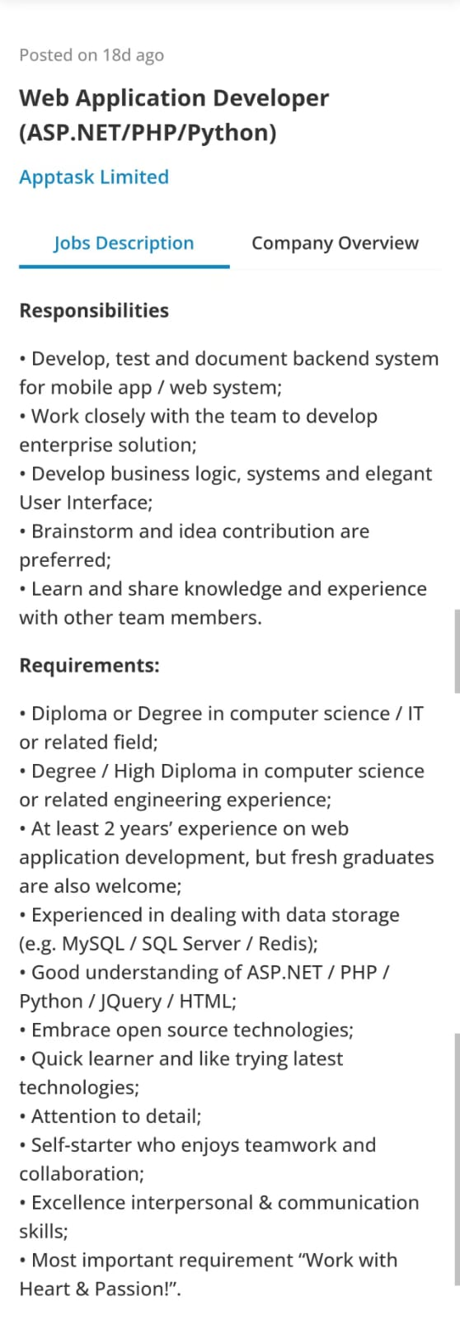

Name:___Owen Wong__________________

Contact No.: ___12345678__________________ Email: _____huangzhongyu113@gmail.com_____________

Work Experience

Life Cafe(June-Aug 2024)
Full-time Waiter
• Serving dishes, preparing sauce
• Managing cleanliness includes tables and floors

Education
Hong Kong Institute of Information Technology(2024-present)
Higher Diploma in AI and Mobile Applications Development
• completed comprehensive training in network and database principles

Ma Kam Chan Memorial English Secondary School(2017-2023)
Hong Kong Diploma of Secondary Education(2023)
•Achieved Level 3 in Liberal Studies

Qualification
Office, Java, Python, HTML ,Oracle

Awards
No

Activities
Website Design, Gaming, Eating, Travling

